Combo Boxes
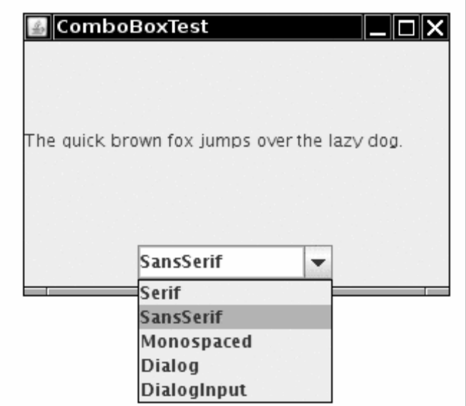

import java.awt.*;
2. import java.awt.event.*;
3. import javax.swing.*;
4.
5. /**
6. * @version 1.33 2007-06-12
7. * @author Cay Horstmann
8. */
9. public class ComboBoxTest
10. {
11. public static void main(String[] args)
12. {
13. EventQueue.invokeLater(new Runnable()
14. {
15. public void run()
16. {
17.
18. ComboBoxFrame frame = new ComboBoxFrame();
19. frame.setDefaultCloseOperation(JFrame.EXIT_ON_CLOSE);
20. frame.setVisible(true);
21. }
22. });
23. }
24. }
25.
26. /**
27. * A frame with a sample text label and a combo box for selecting font faces.
28. */
29. class ComboBoxFrame extends JFrame
30. {
31. public ComboBoxFrame()
32. {
33. setTitle("ComboBoxTest");
34. setSize(DEFAULT_WIDTH, DEFAULT_HEIGHT);
35.
36. // add the sample text label
37.
38. label = new JLabel("The quick brown fox jumps over the lazy dog.");
39. label.setFont(new Font("Serif", Font.PLAIN, DEFAULT_SIZE));
40. add(label, BorderLayout.CENTER);
41.
42. // make a combo box and add face names
43.
44. faceCombo = new JComboBox();
45. faceCombo.setEditable(true);
46. faceCombo.addItem("Serif");
47. faceCombo.addItem("SansSerif");
48. faceCombo.addItem("Monospaced");
49. faceCombo.addItem("Dialog");
50. faceCombo.addItem("DialogInput");
// the combo box listener changes the label font to the selected face name
53.
54. faceCombo.addActionListener(new ActionListener()
55. {
56. public void actionPerformed(ActionEvent event)
57. {
58. label.setFont(new Font((String) faceCombo.getSelectedItem(), Font.PLAIN,
59. DEFAULT_SIZE));
60. }
61. });
62.
63. // add combo box to a panel at the frame's southern border
64.
65. JPanel comboPanel = new JPanel();
66. comboPanel.add(faceCombo);
67. add(comboPanel, BorderLayout.SOUTH);
68. }
69.
70. public static final int DEFAULT_WIDTH = 300;
71. public static final int DEFAULT_HEIGHT = 200;
72.
73. private JComboBox faceCombo;
74. private JLabel label;
75. private static final int DEFAULT_SIZE = 12;
76. }

